PnET-Biosuccession Biomass Output v1.0

Extension User Guide

Eric J. Gustafson

US Forest Service

Northern Research Station

Arjan De Bruijn

Purdue University

Last Revised: May 16, 2014

# PnET-Biosuccession Biomass Output Extension

This document describes the **PnET-Biosuccession Biomass output** extension for the LANDIS-II model. For information about the model and its core concepts including succession, see the *LANDIS‑II Conceptual Model Description.* Readers should read the *LANDIS-II Model User Guide* prior to reading subsequent sections.

Biomass Output is compatible with LANDIS v6.0, and was designed to provide output when the PnET-Biosuccession extension is used.

This output extension produces a number of optional maps.

## Major Releases

### Version 1.0

Initial release.

## Acknowledgements

Funding for the development of the PnET-Biosuccession Biomass Output extension was provided by a grant from the USDA/NASA NIFA/AFRI program to Purdue University. Valuable scientific contributions to the development of the extension were made by Arjan De Bruijn, Brian R. Sturtevant and Eric J. Gustafson.

Funding for the development of LANDIS-II was provided by the Northern Research Station (Rhinelander, Wisconsin) of the U.S. Forest Service. Valuable contributions to the development of LANDIS-II were made by Robert M. Scheller, Brian R. Sturtevant, Eric J. Gustafson, and David J. Mladenoff.

# Input File

The input parameters for this extension are specified in one input file. This text file must comply with the general format requirements described in section 3.1 Text Input Files in the *LANDIS-II Model User Guide*.

## Example inputfile

Note that the order of required keywords “Landisdata”, “TimeStep” and “speces” is prescribed. The position of optional keywords BiomassMapNames to CohortdeathFreqFileName is exchangeable.

LandisData "Output PnET"

Timestep 10

Species ALL

BiomassMapNames output/biomass/{species}/biom-{timestep}.img

LaiMapNames output/LAI/{species}/lai-{species}-{timestep}.img

EstMapNames output/EST/{species}/est-{species}-{timestep}.img

WaterMapNames output/WATER/water-{timestep}.img

AnnualTranspirationMapNames output/Transpiration/Tr-{timestep}.img

SubCanopyPARMapNames output/SCpar/SCpar-{timestep}.img

BelowgroundMapNames output/BGB/BGB-{timestep}.img

WoodyDebrisMapNames output/WoodyDebris/WoodyDebris-{timestep}.img

LitterMapNames output/NonWoodyDebris/Litter-{timestep}.img

AgeDistributionFileNames output/AgeDist/Age-{timestep}.txt

DeathAgeDistributionFileNames output/DeathAgeDistributions.txt

CohortDeathFreqFileName output/CohortDeathFreq.txt

SpeciesSpecEstFileName output/Establishments.txt

## LandisData

The first parameter is the title of the input file:

LandisData “Output PnET”

## Timestep

This parameter is the time step of the extension. Value: integer > 0. Units: years. For example:

Timestep 15

## Species List (required)

First is a species list of the desired species for which to create maps. There is a List parameter, Species, followed by a list of one to many species. Alternatively, the keywords **all** (case insensitive) or none (case insensitive) **can** be used to indicate biomass should be output for every species or for no individual species (just the sum). If **all** is indicated, do not list any species. For example:

Species pinubank

pinuresi

pinustro

poputrem

piceglau

or…

Species All

or…

Species none

## BiomassMapNames (Optional)

BiomassMapNames describes where biomass output maps are placed and their format. These maps will contain total aboveground biomass by species on each cell. (A text file is also written to this folder and contains total biomass and biomass by species (kg/m2) across the landscape at each time step.) The first portion of the name lists the directory where the maps should be placed, relative the location of the scenario text file (e.g., agemaps/). The second portion includes two variables for creating file names. {species} will be replaced with the species name. {timestep} will be replaced with the output time step. Other characters can be inserted as desired. A meaningful file extension (e.g., .img) should also be included.

For example:

MapNames output/biomass/bio-{species}-{timestep}.img

**Note: Biomass output maps are not compatible with the integer-only .gis map output type.**

## LAIMapNames (Optional)

The next parameter, LAIMapNames, describes where LAI output maps are placed and their format. These maps will contain total LAI (leaf area index) by species on each cell. For example:

LaiMapNames output/LAI/{species}/lai-{species}-{timestep}.img

**Note: LAI output maps are not compatible with the integer-only .gis map output type.**

## EstMapNames (Optional)

The next parameter, EstMapNames, describes where Establishment output maps are placed and their format. These maps will contain establishments (as Boolean 0-1) by species on each cell. For example:

EstMapNames output/EST/{species}/est-{species}-{timestep}.img

## WaterMapNames (Optional)

The next parameter, WaterMapNames, describes where Water output maps are placed and their format. These maps will contain bulk soil water (mm) on each cell. For example:

WaterMapNames output/WATER/water-{timestep}.img

**Note: Water output maps are not compatible with the integer-only .gis map output type.**

## AnnualTranspirationMapNames (Optional)

The next parameter, AnnualTranspirationMapNames, describes where Annual Transpiration output maps are placed and their format. These maps will contain annual transpiration values (mm) for each cell. For example:

AnnualTranspirationMapNames output/Transpiration/Tr-{timestep}.img

**Note: Annual Transpiration** **output maps are not compatible with the integer-only .gis map output type.**

## SubCanopyPARMapNames (Optional)

The next parameter, SubCanopyPARMapNames, describes where SubCanopyPAR output maps are placed and their format. These maps will contain SubCanopyPAR values (W/m2) for each cell. For example:

SubCanopyPARMapNames output/SCpar/SCpar-{timestep}.img

**Note: SubCanopyPAR** **output maps are not compatible with the integer-only .gis map output type.**

## BelowgroundMapNames (Optional)

The next parameter, BelowgroundMapNames, describes where Belowground biomass output maps are placed and their format. These maps will contain root biomass values (gDW/m2) for each cell. For example:

BelowgroundMapNames output/BGB/BGB-{timestep}.img

**Note: Belowground** **output maps are not compatible with the integer-only .gis map output type.**

## WoodyDebrisMapNames (Optional)

The next parameter, WoodyDebrisMapNames, describes where WoodyDebris output maps are placed and their format. These maps will contain root biomass values for each cell. For example:

WoodyDebrisMapNames output/WoodyDebris/WoodyDebris-{timestep}.img

**Note: WoodyDebris** **output maps are not compatible with the integer-only .gis map output type.**

## LitterMapNames (Optional)

The next parameter, Lit, describes where WoodyDebris output maps are placed and their format. These maps will contain root biomass values for each cell. For example:

WoodyDebrisMapNames output/WoodyDebris/WoodyDebris-{timestep}.img

**Note: WoodyDebris** **output maps are not compatible with the integer-only .gis map output type.**

## AgeDistributionFileNames (Optional)

## DeathAgeDistributionFileNames (Optional)

Outputs a text file that can be read into excel. It displays the frequency of occurance of cohort ages at the time that these cohorts were removed. It is a tool to test if the longevity of the species was well implemented. In the example below, most cohorts of acerrubr (red maple) die early because the highest frequency of death occurs between 20-30 years. This is an indication that acerrubr in the simulation, establishes successfully. The last cohort removals occur from 270 years old to 290 years old (detail acerrubr). Since this exceeds the documented longevity of red maple, the parameterization here is not ideal. Typically, species specific parameters that implement loss of productivity with age may be underestimated. Acersacc (sugar maple, red marking) and caryglab (pignut hickory, green marking) cohorts die at a very old age. sassalbi (Sassafras) has a close to optimal death age frequency occurance, with a high density of deaths in young cohorts, and with the last cohort removals at occurring around the longevity of the species (here 160 years).

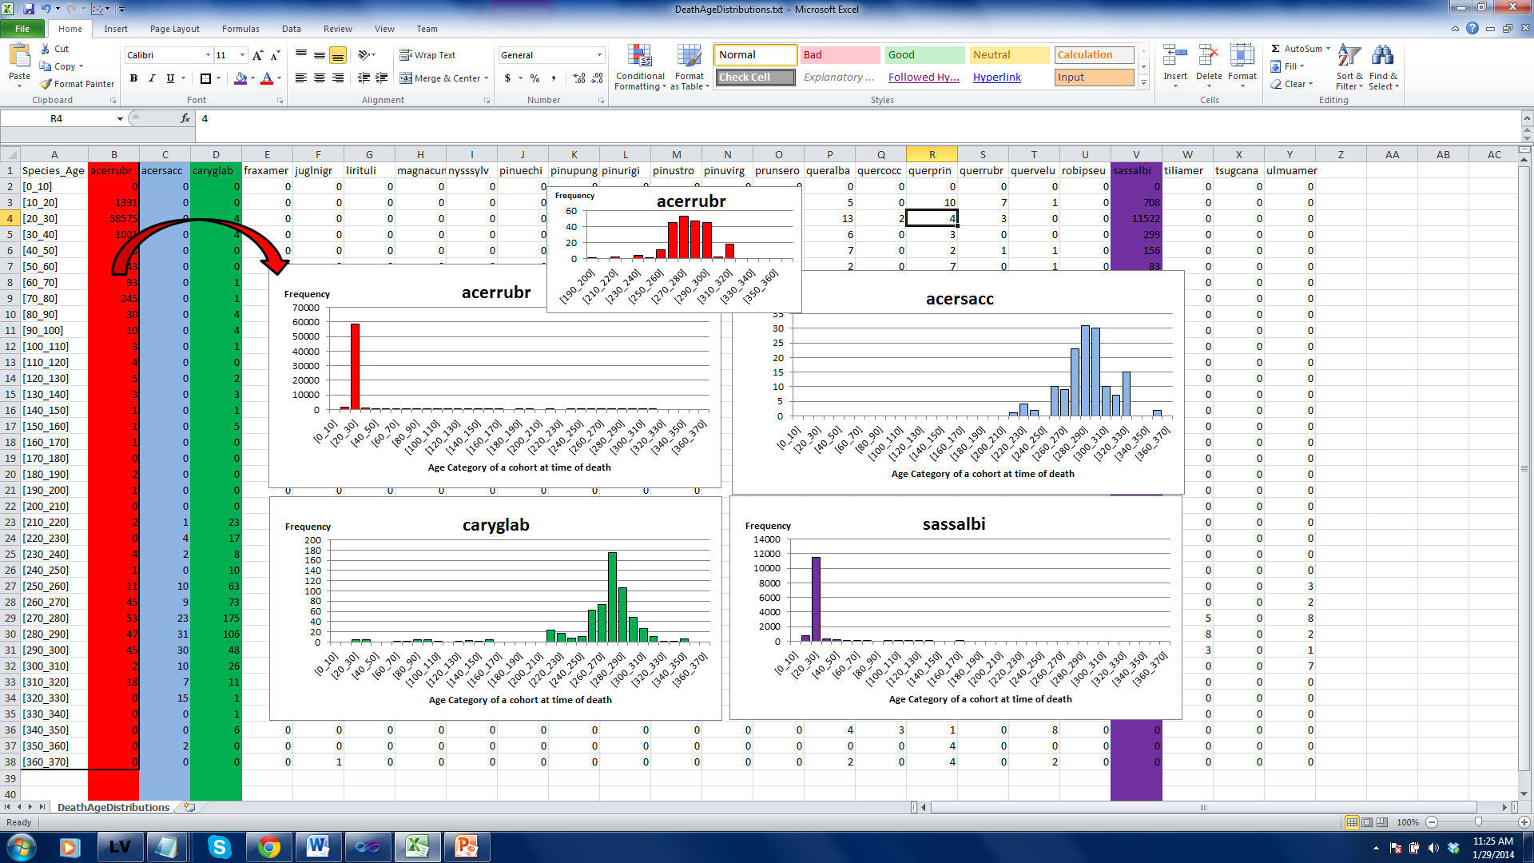

## CohortDeathFreqFileName (Optional)

Outputs a txt file that can be read into excel. Columns contain the number of cohort removals per species, time steps are shown in rows.

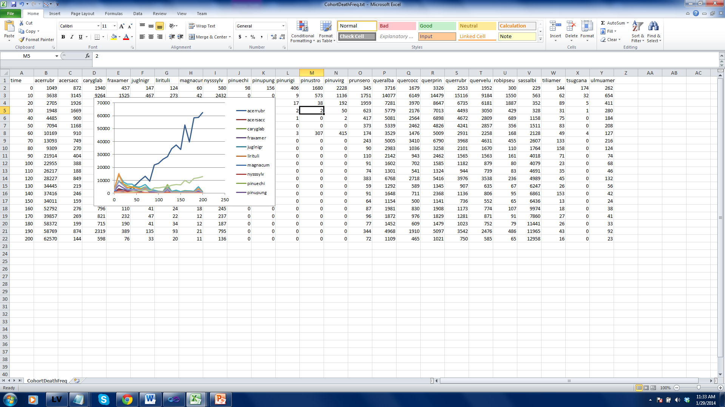

## SpeciesSpecEstFileName (Optional)

Outputs a txt file that can be read into excel. Columns will contain the number of successful establishments per species. The format is identical to the “CohortDeathFreqFile”.